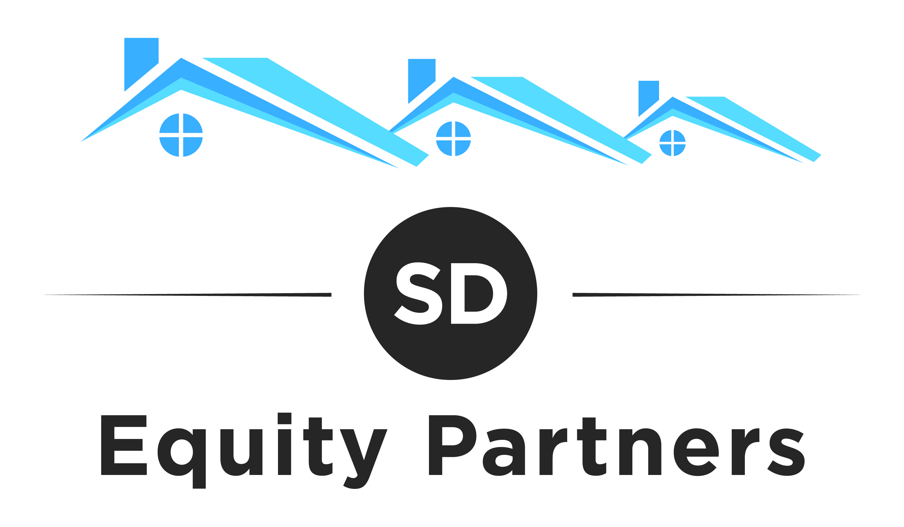
Classified Ads Examples:

==========================================================
FLEET CAR SIGN AD (NO MONTHLY PAYMENTS)
==========================================================

Subject Line: Make $500 to $1000 for just driving your car as usual!

We are looking for help in [city name].

Bottom line we want to pay you for driving your car just like you currently are. We are real estate investors and are looking for distressed homes. What we ask is you put a magnetic sign on your car that you can take on and off as needed. But the more it is on the better. Any time we get a phone call and we buy a home because of your car sign we pay you $500 to $1000. Literally you can make fast money. Help us find houses we can buy in [your town and you can make a QUICK $500 to $1000. We are looking for run down, ugly or vacant houses.

There is no cost to get started, we send you car magnetic and you can put them on and drive like usual. We have a special phone number to identify to you.

If you are interested call [your phone number]
Or email [youremail@domain.com]

==========================================================
FLEET CAR SIGN AD (MONTHLY PAYMENTS)
==========================================================

Subject Line- Put Sign on Car for $25 per Month

We are looking for help in [city name].

We need cars to put our magnetic signs on. We will pay you $20 a month for you to place our “Sell your House for Cash” Sings on your car.

Opportunity for additional $500 to $100 for each house we buy because of your signs.

If you are interested call [your phone number]
Or email [youremail@domain.com]

Limited to the first 20 people who call

==========================================================
BIRD DOG AD
==========================================================

Subject Line: Make $500 to $1000 Locating Run-Down Houses

We are looking for help in [your city]. And you can make a quick $500 to $1000

We are looking for run down houses in need of repairs, ugly or vacant homes.

You can submit your information by calling or emailing us. The more information you can provide about the property and the seller, the faster we can determine if the deal will work. However even if you have just an address for the property we can track down the homeowner to make an offer so you can get paid if we by the home.

To save us both time and energy, we are NOT looking of houses where the seller wants full price. If we can’t buy at a SIGNIFICANT discount we don’t buy and unfortunately you won’t make any money. Most of the homes we buy are in need of repairs and the seller does not have the money to fix the property up. In addition the seller cannot sell the home because buyers not able to get a traditional loan due to the property conditions is in need of repairs and will not qualify for a loan.

Start looking for houses in need of work and then call or email me at ________________

We will call or email you as soon as we have a contract on the property and you will be paid the day we close at the title company. Please indicate whether you would prefer to have a check or have the money wired into your account.

If you are interested call [Your Phone Number]
Or email [youremail@domain.com]

==========================================================
CASH FOR YOUR HOME AD
==========================================================
Subject: Cash for your home ANY area ANY condition

We pay cash for your home and close on the date of your choice. We specialize in helping get cash for people fast on their home. Most homes are in need of repairs and the owner is unwilling or unable to pay for the repairs. This could be a tenant that trashed the property, an inherited property, or a violation from the city.

No matter the property we can buy properties because we pay cash for the home and are able to buy regardless of the needed repairs. Lets us buy your home that is in need of repairs

Call us so we can talk about how we can help with your real estate needs. We promise a fair price and fast cash.

If you are interested call [Your Phone Number]
Or email [youremail@domain.com]

